**Python – 101**

Python Installation Instruction

**Python IDE - Anaconda**

1. **Download Anaconda directly from CONTINUUM** – Anaconda is a python distribution which includes all the common scientific Python packages as well as many packages related to data analytics and big data.

**Please install Python 2.7 and follow instructions below:**

Window users:<http://docs.continuum.io/anaconda/install#anaconda-for-windows-install>

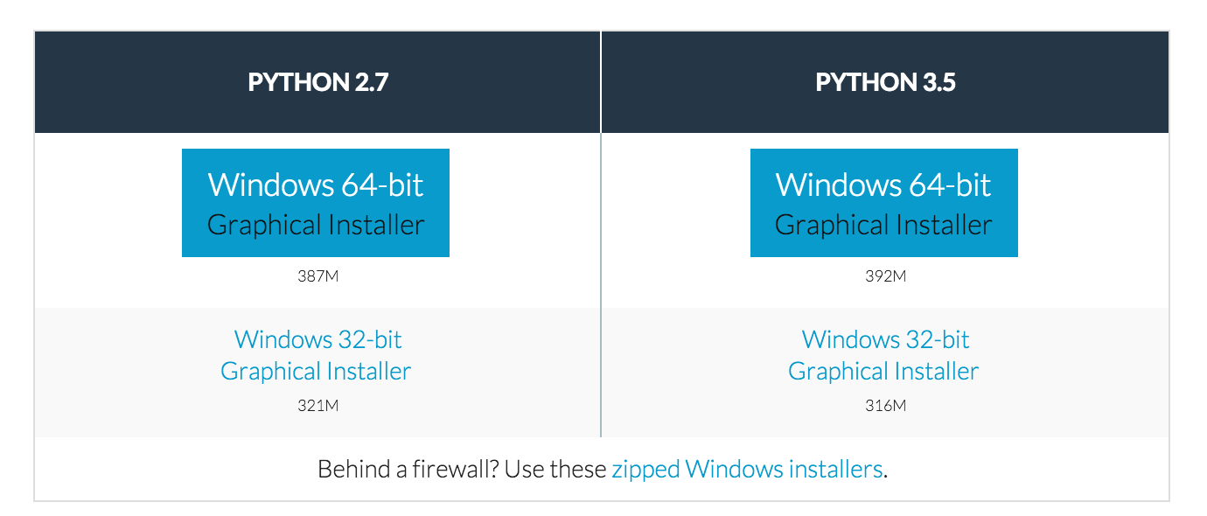

Mac Users:<http://docs.continuum.io/anaconda/install#anaconda-for-os-x-graphical-install>

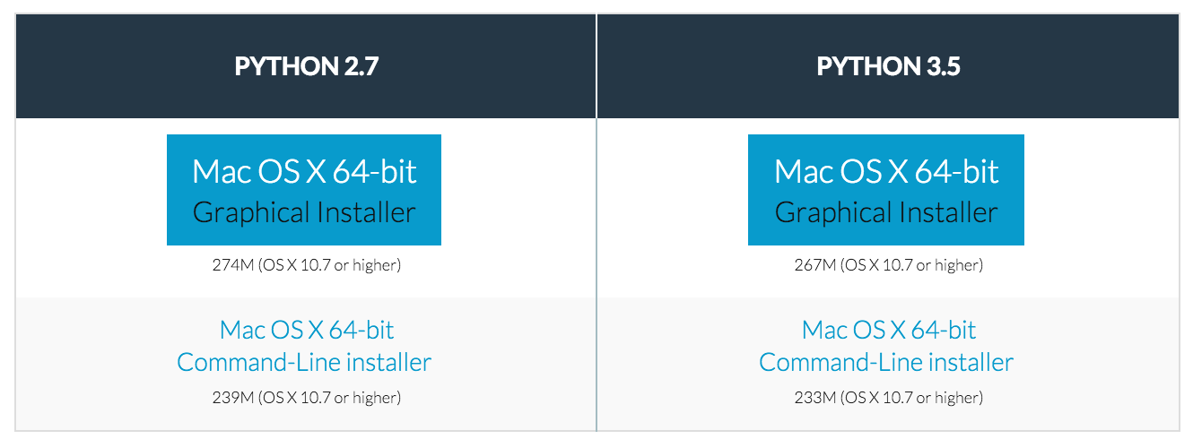

1. **Launch your Python IDE (Spyder) from Anaconda** – Go to your cmd (Window users) or terminal (Mac Users)

**Window users: CMD**

1. Search for “cmd”

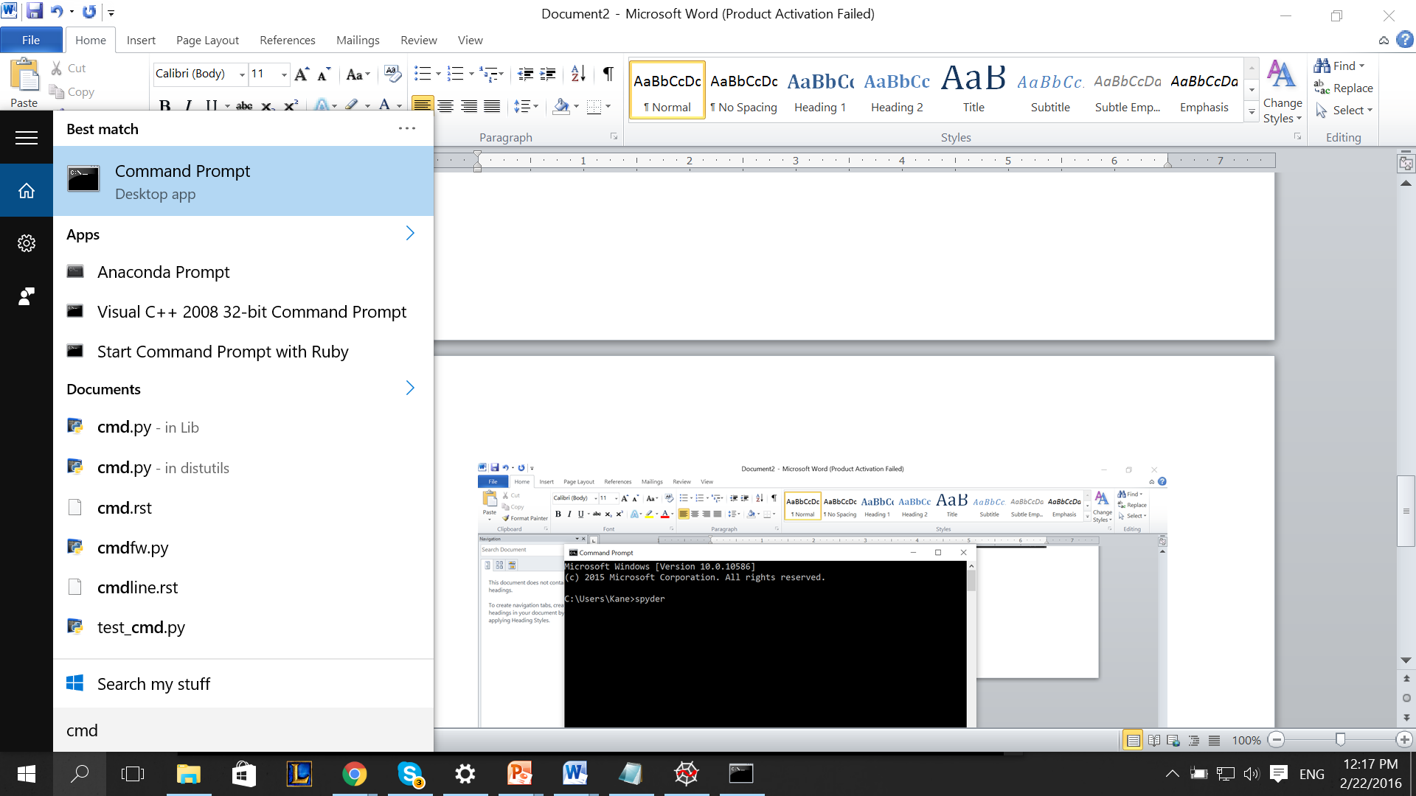

1. Type “spyder” in cmd and enter.

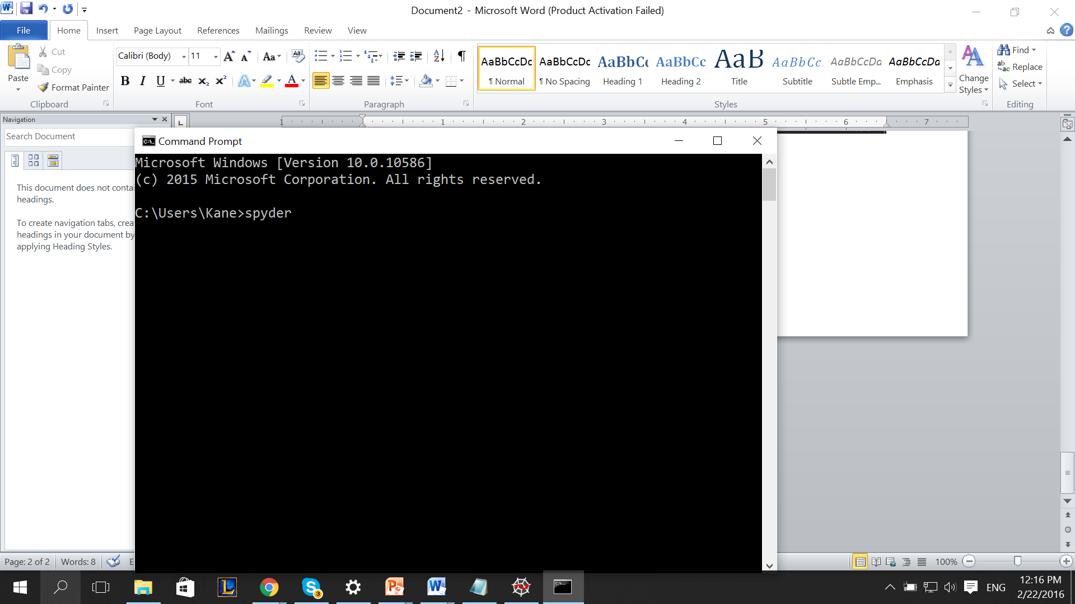

**Mac users: Terminal**

1. Press “command + space” and search field will pop up, then you search for “terminal”

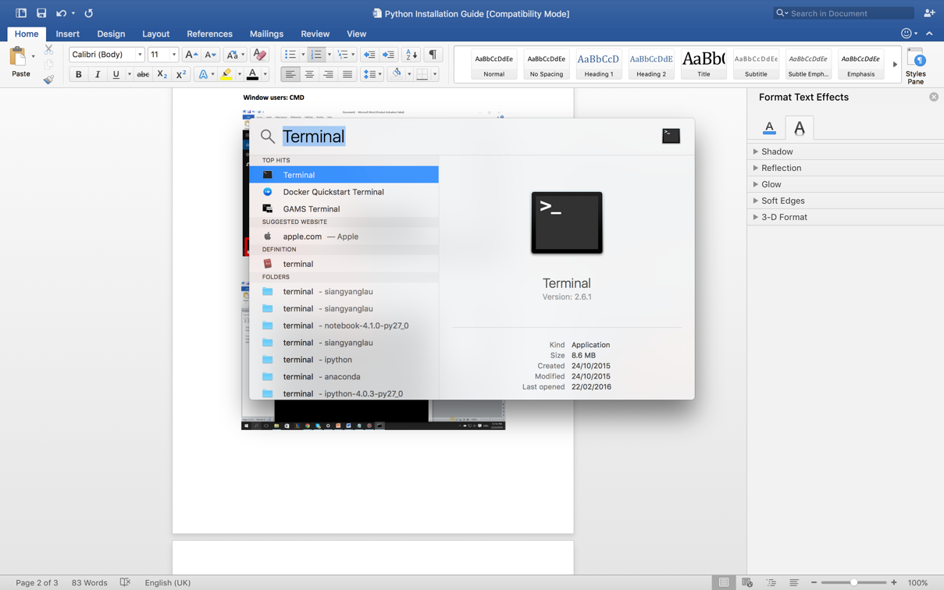

1. Type “spyder” in terminal and enter.

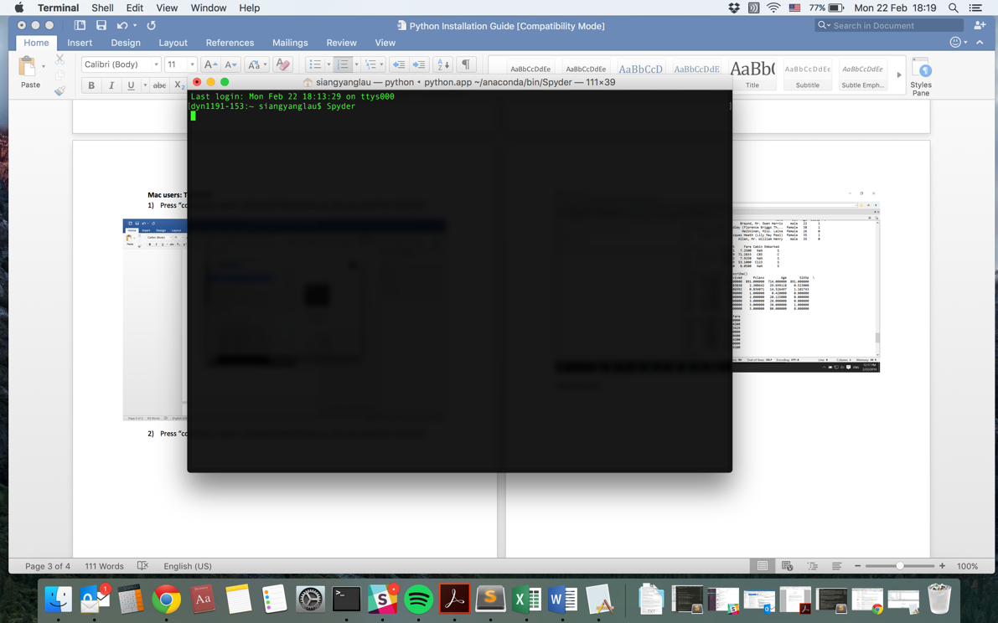

You are done!